  - Case Project

jQuery Drop-Down Menu

Life on Rocks Wildlife Cruises
In this case study, you will work on a web site for Life on Rocks Wildlife Cruises, a company in Monterey, California, that offers boat trips to view marine animals and seabirds. The main page of the site has been designed, and you have been hired to add drop-down menus to the navigation section. The design specifies that when a user moves the mouse pointer over a navigation bar item, the submenu showing its related options should be displayed. When the user moves the mouse pointer off that navigation bar item, the submenu should be hidden. Although you could create these drop-down menus using the JavaScript concepts you have learned, jQuery enables you to create this feature using much less code, so you’ll use the jQuery library for this task. The owners want their site to work for IE users, so you’ll use jQuery 1.x. The screenshots below show a working drop-down menu on a desktop browser, and on a handheld browser.
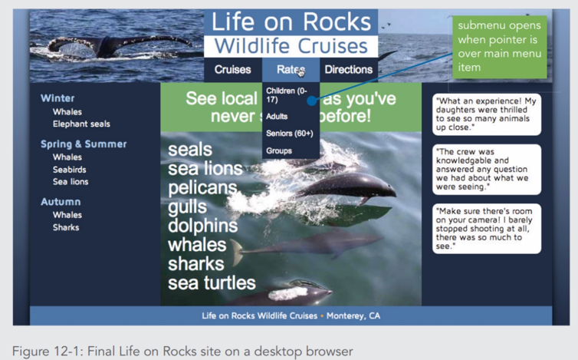 | 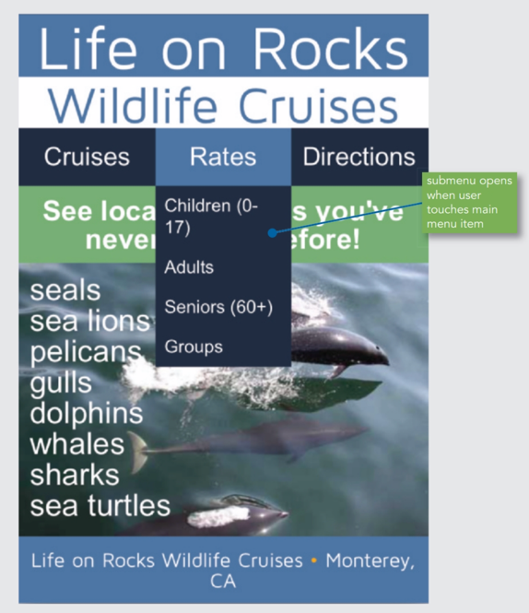
Final Life on Rocks site on a desktop browser | Final Life on Rocks site on a handheld browser

Including the Library
The first step in using jQuery is to link the .js file that contains the library to your HTML document. You can download the .js file for any version of the jQuery library for free from jquery.com. You can then place the downloaded file in the same location as your HTML document and link to the local file, just as you would for code you write yourself. However, because jQuery is so widely used, you have another option: instead of downloading the file and hosting it on your own server, you can simply specify the location in your HTML document of the jQuery file on a publicly accessible server. Such servers, known as content delivery networks (CDNs), are optimized for quick delivery of files across the globe, and linking to a file on a CDN provides an improved user experience in many situations. jQuery is available through a CDN hosted by jquery.com, as well as those maintained by Google, Microsoft, and other companies.
You’ll start your work on the Life on Rocks drop-down menus by examining the main web page in your browser and then adding a script element that links to a local copy of the jQuery library file. To examine the Life on Rocks web page and link to the jQuery library:

- In your text editor, open the jquery-1.11.1.js file provided in the project files, and then examine the code. This file contains the jQuery library. Note that all the code is written in JavaScript.
- Open the jquery- 1.11.1.min.js file provided in the project files, and then examine the code. This file contains the minified version of the same code. Because you don’t need to make changes to the jQuery library file, you’ll link this minified version to your HTML document.
- In your editor, open the rocks.htm file, and then in the comment section, add your name and today’s date where indicated.
- Save your changes, and then scroll through the document and familiarize yourself with its content. The body section contains two div elements containing images, followed by a header section and a nav section. The nav section contains an unordered list for the navigation bar elements, and each list item contains a nested unordered list for its submenu. The rest of the page consists of two aside elements, an article element, and a footer element.
- At the end of the body section, just before the closing </body> tag, add the following script element to link to the minified jQuery file.
<script src="jquery-1.11.1.min.js"></script>
- Save your changes to rocks.htm, open rocks.htm in a browser, and then move your mouse pointer over the navigation bar. Note that the submenus are hidden and moving the mouse pointer over the navigation bar text has no effect. Your first task will be to write code that displays each submenu when the mouse pointer is over the related navigation bar text.
In the Life on Rocks navigation bar, the top-level unordered list has the class name mainmenu. To select each list item within this list, your jQuery statements must start as follows: $("ul.mainmenu li")
Note that this code doesn’t end with a semicolon because it’s not a complete statement—it’s just the selector portion of the statement. Next, you’ll learn about methods you can specify to create a complete statement.

In the Life or Rocks navigation bar, your drop-down menus will work by showing and hiding the unordered lists that are children of the top-level list items. You can add the children() method to your existing selector to change the selected items to the children of the original selection, as follows:
$("ul.mainmenu li").children()
The style sheet for the Life on Rocks site contains a class named show that sets the value of the CSS display property to block. By applying this property to the children of a top-level list item, you make the nested list containing the submenu items visible. The following complete jQuery statement makes all submenus visible by assigning them all the class name show:
$("ul.mainmenu li").children("ul").addClass("show");

Next, you’ll create a JavaScript document, link it to your HTML document, and add a jQuery statement that makes all the submenus visible. To create a jQuery statement that makes all the submenus visible:
- In your text editor, create a new JavaScript document containing the following comment, adding your name and today’s date where indicated:
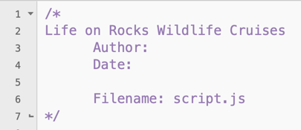
- Save the file as script.js
- Below the comment, enter the following jQuery statement:
$("ul.mainmenu li").children("ul").addClass("show");
This statement selects the li elements that are within the ul element with the class name mainmenu, traverses to the children of the selected elements, and then adds the class name show to the child elements.
- Save your changes to script.js then switch to rocks.htm in your editor.
- At the end of the body section, just before the closing </body> tag, enter the following script element to link the script.js file you just created:
<script src="script.js"></script>
- Save your changes to rocks.htm, and then refresh or reload rocks.htm in your browser. All three submenus are now displayed.

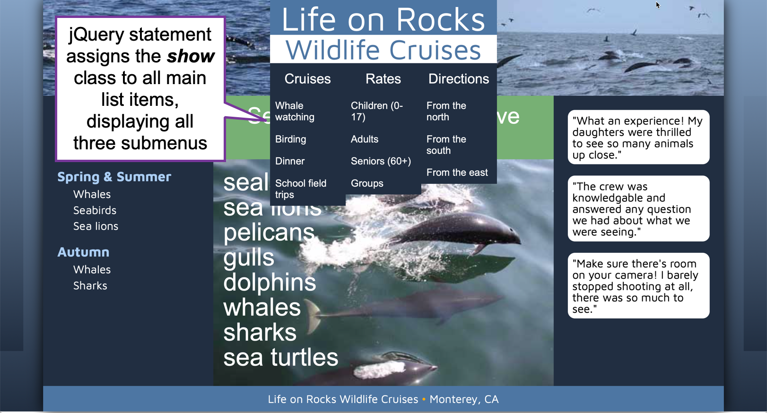
Life on Rocks page showing all three submenus

Caution: Be sure the script element that links to the script.js file follows the script element that links to the jQuery library file. This order ensures that browsers parse the contents of the jQuery library before attempting to interpret the jQuery statements in script.js. Otherwise, the jQuery syntax in script.js could cause syntax errors if browsers encounter it before parsing the jQuery library.
Next, you will create two functions for the Life on Rocks drop-down menus. The display() function will display a submenu, and the hide() function will hide a submenu. You’ll then add an event handler for the hover event, specifying the display() function as the code to execute when the pointer enters an element and the hide() function as the code to execute when the pointer leaves an element. Your functions will use the event.currentTarget property to identify which element’s submenu to show or hide.

To create functions and an event listener using jQuery:
- Return to script.js in your editor.
- Comment out the statement $("ul.mainmenu li").children("ul") .addClass("show");
- Below the commented-out statement, enter the following code to create the display() function:
function display(event) {
}
This function takes a single parameter, event, which references the event that fired to call the function.
- Within the display() function, enter the following statement:
$(event.currentTarget).children("ul").addClass("show");
This statement replaces the selector you previously used ("ul.mainmenu li") with a reference to the currentTarget property of the event parameter. The value of this property is the li element that the mouse pointer is currently over.
- Below the closing } for the display() function, enter the following hide() function:
function hide(event) {
$(event.currentTarget).children("ul").removeClass("show");
}
This function works similarly to the display() function, but instead of the addClass() method, it uses the removeClass() method to remove the show class and return the submenu to its default display property value of none.
- Below the closing } for the hide() function, enter the following statement:
$("ul.mainmenu li").hover(display,hide);
This statement incorporates the same selector you used in the previous steps to select all top-level list items. It then uses the hover() method to specify code to fire in response to the hover event. The method takes two arguments: the first specifies the event handler for when the mouse pointer enters the element, and the second specifies the event handler for when the mouse pointer leaves the element.
- Save your changes to script.js, reload rocks.htm in your browser, and then move the mouse pointer over each of the items in the navigation bar. When you move the mouse pointer over a menu item, its submenu is displayed, and when you move the mouse pointer off the menu item, its submenu is once again hidden.

